LIFELINE – BLOOD BANK
MANAGEMENT SYSTEM
A GUI-Based Blood Bank Management Desktop Application using Python, Tkinter and SQLite

A Major Project Report Submitted by
SHAIK SHAHEDA
ENROLLMENT NO : 92500116016

ATHOTA GIRISH CHOWDARY
ENROLLMENT NO : 92500116008

in partial fulfillment for the award of the degree of
Bachelor of Technology
In
Computer Engineering-AI, ML & DS (P.B.L.)

Faculty of Engineering & Technology
Marwadi University, Rajkot
2025-26

Faculty of Engineering & Technology
Marwadi University
Department of Computer Science & Engineering – AI, ML & DS (P.B.L.)
2025-26

CERTIFICATE
This is to certify that the project entitled "LifeLine – Blood Bank Management System – A GUI-Based Blood Bank Management Desktop Application using Python, Tkinter and SQLite" has been carried out by Shaik Shaheda (Enrollment No. 92500116016) and Athota Girish Chowdary (Enrollment No. 92500116008) as a group major project, under my guidance, in partial fulfillment of the degree of Bachelor of Technology in Computer Engineering – AI, ML & DS (P.B.L.) of Marwadi University, Rajkot during the academic year 2025-26.

Date: ____________________

Internal Guide | Head of the Department
Mukhtar Sama  Assistant Professor | Dr. Nilesh Kumar Jadav  Head & Associate Professor
STUDENT DECLARATION
We, Shaik Shaheda (Enrollment No. 92500116016) and Athota Girish Chowdary (Enrollment No. 92500116008), hereby declare that this project report titled "LifeLine – Blood Bank Management System – A GUI-Based Blood Bank Management Desktop Application using Python, Tkinter and SQLite" is our own group work, prepared under the guidance of Mukhtar Sama as part of the Major Project requirement at Marwadi University.
We understand every screen, function, database table, and SQL statement included in this submission, and we are able to explain and, if required, modify or execute any part of the code during the viva voce examination. Wherever ideas, code fragments, libraries, APIs, or reference material from external sources (including AI-assisted tools) have been used, they have been acknowledged in the References section of this report.

Signature (Shaik Shaheda): _______________________ Date: ______________
Signature (Athota Girish Chowdary): _______________________ Date: ______________
ACKNOWLEDGEMENT
The successful completion of this project would not have been possible without the support, guidance, and encouragement of a number of people, and we take this opportunity to express our sincere thanks to each of them.
First and foremost, we would like to express our heartfelt gratitude to our faculty guide, Mukhtar Sama, for the continuous guidance, patient mentorship, and constructive feedback provided at every stage of this project — from the initial planning of the database tables to the final review of the working application. Their suggestions on structuring the billing and stock rules, validating user input, and keeping the interface consistent helped us significantly improve the quality of our work.
We are equally grateful to the Department of Computer Science & Engineering – AI, ML & DS (P.B.L.), Marwadi University, for providing us with the resources, laboratory access, and a structured learning environment that made this project possible. The concepts we learned during our earlier Python coursework and our minor project, the Python Learning Platform, gave us the foundation on which this larger, database-driven application was built.
We would also like to thank our fellow classmates and peers, with whom we had many useful discussions while debugging Tkinter layouts and SQLite queries; their observations as test users of early versions of the application helped us identify and fix several usability issues before final submission.
Finally, we acknowledge the official Python, Tkinter, and SQLite documentation, which served as our primary technical references throughout development, as listed in the References section. We also thank our families for their constant encouragement and support throughout the duration of this project.
ABSTRACT
This project presents the design and implementation of "LifeLine – Blood Bank Management System", a single-file desktop application built with Python's standard Tkinter toolkit and an SQLite database. The system addresses a common difficulty faced by small blood banks and hospital blood units: stock levels, donor collections, doctor and nurse details, and patient billing are often kept in separate paper registers, which makes it hard to know at any moment how many units of each blood group are actually available.
LifeLine brings these activities into one dashboard-style application with a navigation sidebar and six pages: Dashboard, Blood Inventory, Doctors, Available Nurses, Collections, and Payments & Bills. Data is stored permanently in a local SQLite file (lifeline_stylish.db) using six tables — doctors, nurses, blood_stock, collections, bills, and hospital_daily_bills. The Dashboard shows live summary cards and a bar chart drawn on a Tkinter Canvas; the Inventory page lists the eight blood groups with a Low stock flag for fewer than 10 units and lets the administrator update units and service cost; the Doctors and Nurses pages maintain staff directories; the Collections page records donor collections and adds one unit to stock when a collection is marked Collected; and the Payments & Bills page creates patient bills, checks stock, reduces the stock automatically, simulates an online or cash payment, and produces a separate hospital daily summary bill.
All user input is validated before it reaches the database, all SQL statements use parameterised queries, and the application is intentionally labelled as an educational demonstration: service costs are illustrative and the online payment is simulated. The result is a compact, working example of event-driven GUI programming combined with relational database design, using only Python's standard library.
INDEX
- 1. Introduction
- 2. Problem Statement and Objectives
- 3. Requirement Analysis
- 4. Proposed Design
- 5. Tools and Concepts Used
- 6. Implementation
- 7. Testing and Debugging
- 8. Results and Discussion
- 9. Conclusion and Future Scope
- References
LIST OF FIGURES
Figure | Title
Figure 1 | Project Workflow Flowchart
Figure 2 | System Architecture / Block Diagram
Figure 3 | Input-Process-Output (IPO) Diagram
Figure 4 | Database Schema / Entity Relationship Model
Figure 5 | Module / Function Structure (procedural design)
Figure 6 | User Interface Wireframes (Dashboard and Payments & Bills)
Figure 7 | Use Case Diagram
LIST OF TABLES
Table | Title
Table 1 | Database Tables and Their Purpose
Table 2 | Application Pages and Main Functions
Table 3 | Initial Blood Stock and Service Cost (Seed Data)
Table 4 | Functional Test Cases

1. INTRODUCTION
A blood bank is a place where blood donated by volunteers is collected, tested, stored, and later issued to patients who need it. Managing this work well depends on knowing, at every moment, how many units of each blood group are available, who collected them, which doctors and nurses are on duty, and what has been billed to patients. In many small centres these records are still maintained in paper registers or scattered spreadsheets, which makes stock counts slow to check and easy to get wrong.
This project, "LifeLine – Blood Bank Management System", was undertaken as our major project. It is a desktop application written in Python that uses the Tkinter toolkit for the graphical interface and an SQLite database for permanent storage. It brings inventory, staff directories, donor collections, patient billing, and daily hospital summaries into one application with a clean, dashboard-style interface.

1.1 Target User Profile
The application is designed for a blood bank administrator or hospital blood-unit staff member who is comfortable with basic computer use but does not need any technical knowledge. The user needs a desktop or laptop computer with Python 3.8 or later installed; no database server, internet connection, or additional software is required, because SQLite is built into Python.

1.2 Motivation
Our minor project, the Python Learning Platform, kept all its progress in memory, so everything was lost when the program closed. For the major project we wanted to move to the next step of a real application: storing data permanently in a relational database, validating user input, and linking several related records together (for example, a bill that reduces the stock of a blood group). A blood bank was chosen because it has clear, real-world rules — stock must never go below zero, a collection should only increase stock when it is actually completed, and a bill must match the unit cost at the time of issue — which are ideal for practising database design and careful programming.

1.3 Scope and Disclaimer
LifeLine is an educational demonstration. The service costs are illustrative processing charges and not a selling price for blood, the online payment is simulated and moves no money, and real blood collection must follow proper medical procedures. The application records and displays information; it does not make any medical decision.

2. PROBLEM STATEMENT AND OBJECTIVES

2.1 Problem Statement
Small blood banks and hospital blood units often track blood stock, donor collections, staff details, and billing in separate paper or spreadsheet records. This makes it difficult to know current stock by blood group, to spot low-stock groups early, to keep billing consistent with stock issued, and to produce a daily summary for hospital records — leading to delays and errors.

2.2 Objectives
- To design and implement a GUI-based blood bank management application using Python and Tkinter with a sidebar-driven, dashboard-style interface.
- To store all data permanently in an SQLite database with separate, well-defined tables for doctors, nurses, blood stock, collections, bills, and daily hospital bills.
- To display live stock levels for all eight blood groups, with a clear Low stock indicator when fewer than 10 units remain, and to allow the administrator to update units and service cost.
- To maintain directories of doctors and nurses, including experience and availability, and to allow new staff to be added.
- To record donor collections, accepting only available doctors, and to increase stock only when a collection is confirmed as Collected.
- To create patient bills that calculate the total from the current service cost, refuse requests larger than the available stock, reduce stock automatically, and support a simulated online payment or a cash-due option.
- To generate a separate hospital daily summary bill for each date and keep a history of these summaries.
- To validate every user input and show clear messages for invalid data.

3. REQUIREMENT ANALYSIS

3.1 Functional Requirements
- The system shall display a dashboard showing total available units, number of blood groups in stock (out of 8), number of available doctors, number of collection records, and a bar chart of units by blood group.
- The system shall list all blood groups with units, service cost, and a stock status, and shall let the user update units and service cost for a selected group using non-negative values only.
- The system shall list doctors and nurses and let the user add new ones with name, specialization/details, experience, and availability (Available or On Leave).
- The system shall register a donor collection with donor name, blood group, volume in mL, doctor, and status (Collected or Not Collected), and shall allow only doctors whose availability is Available.
- The system shall ask for confirmation before saving a collection marked Collected, and shall add one unit to the stock of that group only in that case.
- The system shall create a patient bill for a chosen blood group and unit count (or a volume such as 500ml, counted as one bag), show an estimated total while the user types, reject requests larger than the available stock, and reduce the stock after the bill is saved.
- The system shall offer two payment methods — Online Payment (Demo) and Cash at Hospital — and mark bills as Paid (Demo) or Cash Due respectively.
- The system shall generate one separate hospital daily bill per date summarising the number of patient bills, total units issued, and total amount, and shall show a history of these bills.

3.2 Non-Functional Requirements
- Usability: a consistent navy, red, and teal colour theme, one font family (Segoe UI), a persistent sidebar, and clear pop-up messages for success and errors.
- Reliability: data is committed to SQLite after every change and the database connection is committed and closed when the window is closed.
- Data integrity: parameterised SQL queries are used throughout, and numeric fields are validated before saving.
- Portability: the application uses only Python's standard library (tkinter, sqlite3, datetime), so no installation of third-party packages is needed.
- Simplicity: the whole application is a single Python file, which keeps the schema, seed data, and interface logic together for easy review.

3.3 Software and Hardware Requirements
Category | Requirement
Operating System | Windows (recommended – the interface uses the Segoe UI font), macOS or Linux with Python 3.8+
Language | Python 3.8 or later
Libraries | tkinter (with ttk and messagebox), sqlite3, datetime — all part of the Python standard library
Database | SQLite (file lifeline_stylish.db, created automatically in the working folder)
IDE | Visual Studio Code (or any text editor/IDE)
Hardware | Any standard desktop or laptop capable of running Python; recommended screen size of at least 1080 × 700 pixels

3.4 Input-Process-Output (IPO) Analysis
The overall Input-Process-Output relationship of the system is summarised below and illustrated in Figure 3 (Section 4).
- Input: sidebar page selections; stock units and service cost; doctor and nurse details; donor name, blood group, volume, doctor, and status; patient name, blood group, units or volume, and payment method.
- Process: numeric and empty-field validation, doctor-availability check, stock-sufficiency check, billing calculation (unit cost × units), stock increase or decrease, and aggregation of the day's bills.
- Output: dashboard cards and chart, inventory and directory tables, collection and bill tables, receipt pop-ups, the hospital daily bill, and the daily bill history window.

4. PROPOSED DESIGN
This section presents the workflow, architecture, data, and interface design of LifeLine through seven diagrams, each drawn specifically for this project to match the implemented code.

4.1 Project Workflow Flowchart
Figure 1 shows the complete flow of the application: database creation and seeding on first run, building the sidebar and dashboard, the choice of page by the administrator, the three groups of operations, committing to the database, and closing the application.
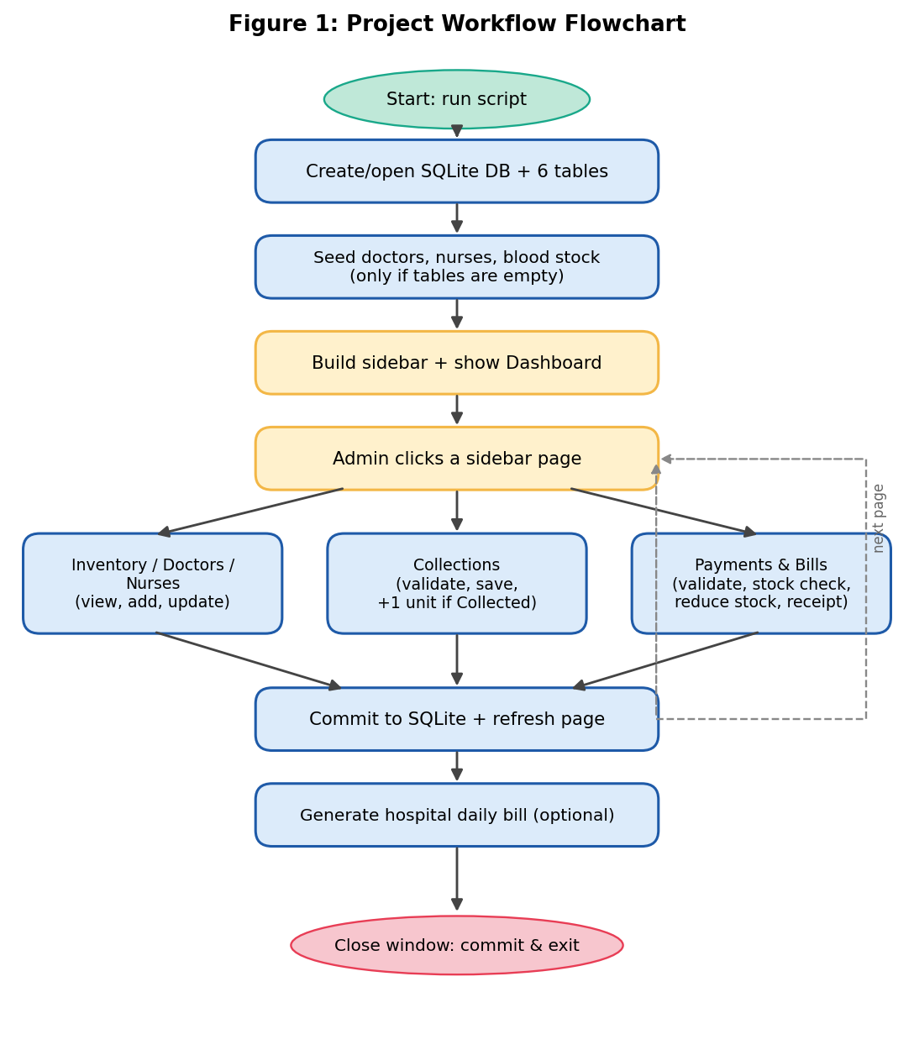
Figure 1: Project Workflow Flowchart

4.2 System Architecture / Block Diagram
Figure 2 shows the three logical layers used within the single Python file: a Tkinter presentation layer (sidebar, cards, tables, forms, and pop-ups), an application/control layer made of module-level functions (one show_... function per page plus validation and billing rules), and a data layer using the sqlite3 module with a shared connection and cursor.
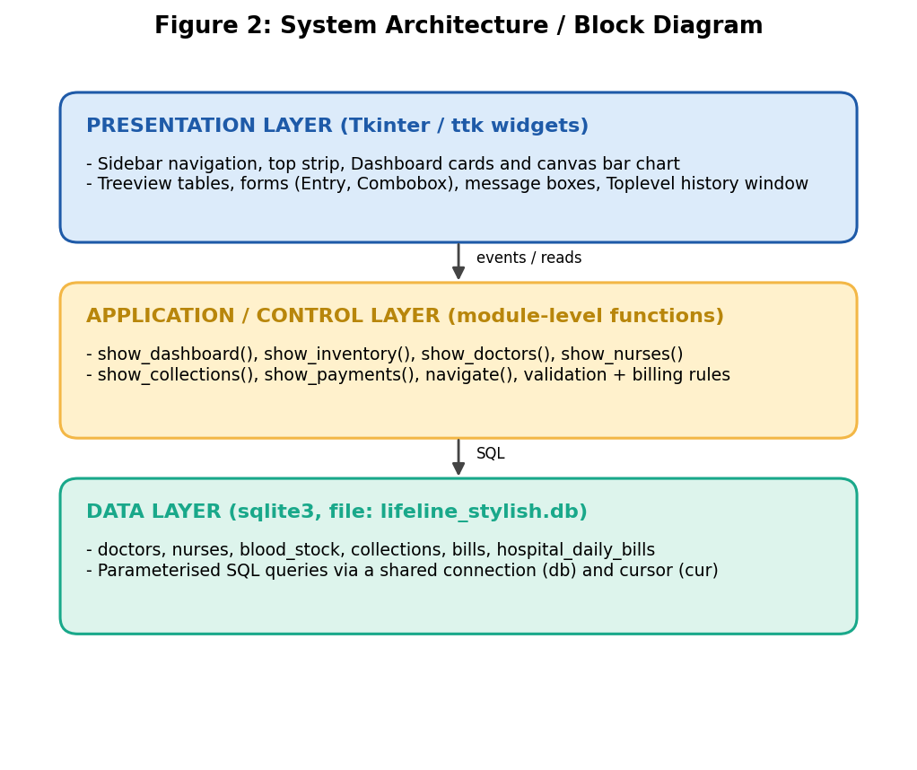
Figure 2: System Architecture / Block Diagram

4.3 Input-Process-Output Diagram
Figure 3 summarises the IPO analysis from Section 3.4 in diagram form.
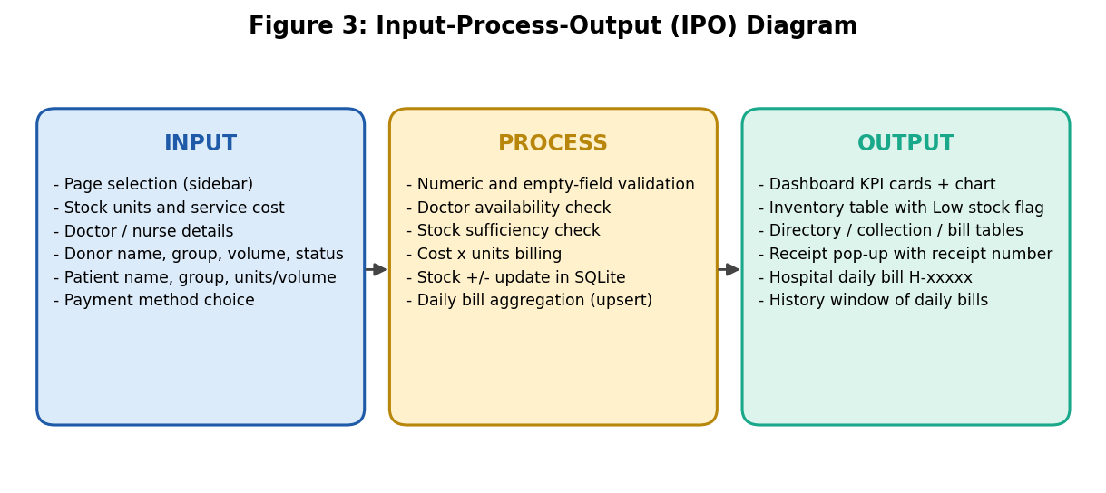
Figure 3: Input-Process-Output (IPO) Diagram

4.4 Database Design
The data layer consists of six tables. Figure 4 shows their columns and the logical links between them, and Table 1 explains the purpose of each table. The relationships are logical: collections.blood_group and bills.blood_group refer to blood_stock.blood_group, and collections.doctor stores the name of a doctor from the doctors table. The code does not declare FOREIGN KEY constraints; consistency is maintained by the application — for example, the blood-group list in every form comes from the blood_stock table and the doctor list in the collection form comes from available doctors only.
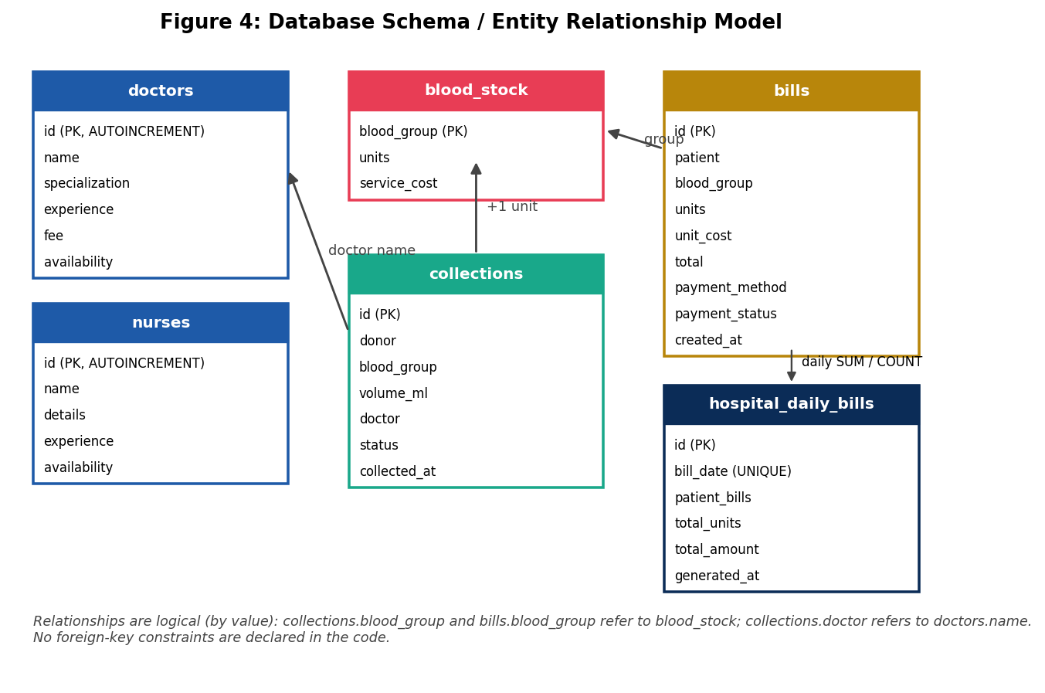
Figure 4: Database Schema / Entity Relationship Model
Table 1: Database Tables and Their Purpose
Table | Key columns | Purpose
doctors | id (PK), name, specialization, experience, fee, availability | Doctor directory with experience, consultation fee, and Available / On Leave status
nurses | id (PK), name, details, experience, availability | Nurse directory with a short description of duties
blood_stock | blood_group (PK), units, service_cost | One row per blood group with current units and illustrative service cost per unit
collections | id (PK), donor, blood_group, volume_ml, doctor, status, collected_at | Record of every donor collection attempt and its status
bills | id (PK), patient, blood_group, units, unit_cost, total, payment_method, payment_status, created_at | Individual patient bills; the receipt number is the id
hospital_daily_bills | id (PK), bill_date (UNIQUE), patient_bills, total_units, total_amount, generated_at | One summary row per date for hospital records

4.5 Module / Function Structure
Unlike the minor project, which used a single class, LifeLine is written in a procedural style with module-level functions. Figure 5 groups them: UI helper functions (button, heading, card, make_table, clear_content, stock_rows), the navigation function, and one show_... function per page, each containing its own nested helper functions such as update_stock, add_doctor, save_collection, and create_bill. The shared database connection db and cursor cur are module-level variables.
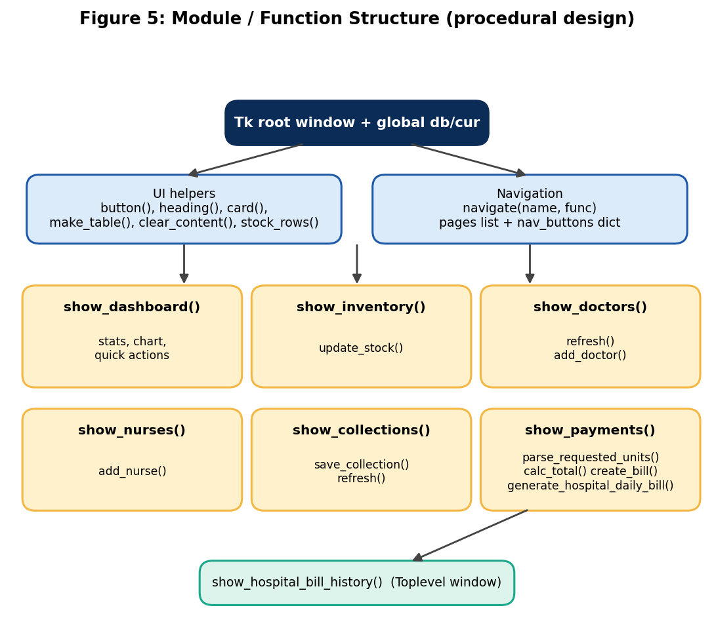
Figure 5: Module / Function Structure (procedural design)
Table 2: Application Pages and Main Functions
Page | Function | Main operations
Dashboard | show_dashboard() | KPI cards, canvas bar chart, quick-action buttons
Blood Inventory | show_inventory() | View stock and status; update units and service cost
Doctors | show_doctors() | View directory; add doctor with availability
Available Nurses | show_nurses() | View directory; add nurse with availability
Collections | show_collections() | Register collection; increase stock when Collected
Payments & Bills | show_payments() | Create bill, reduce stock, generate daily hospital bill
Bill History (pop-up) | show_hospital_bill_history() | Toplevel window listing saved daily bills

4.6 User Interface Wireframes
Figure 6 shows simplified wireframes of two representative screens — the Dashboard and the Payments & Bills page — following the layout, colours, and widget placement used in the Tkinter code: a dark navy sidebar on the left, a white top strip, and a light content area with cards, forms, and tables. These are design drawings; screenshots of the running application are to be added in Section 8.1.
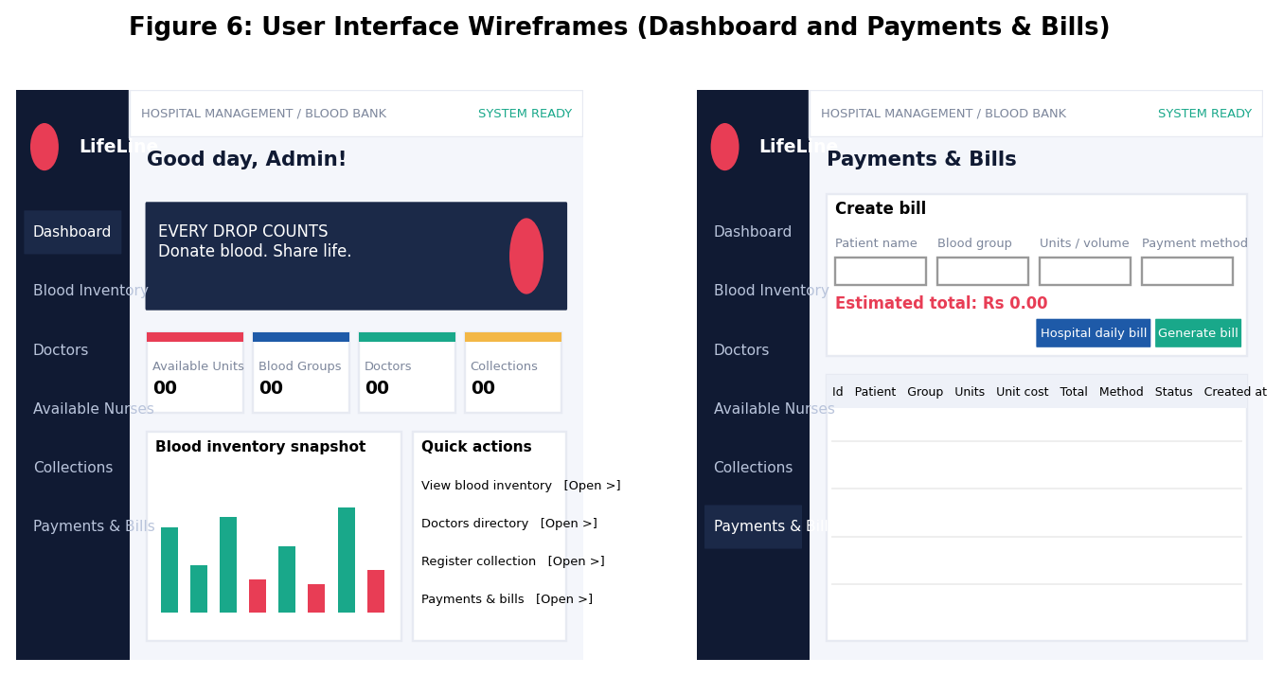
Figure 6: User Interface Wireframes (Dashboard and Payments & Bills)

4.7 Use Case Diagram
Figure 7 shows the primary actor, the Admin / Blood Bank Staff member, and the main actions available to them in the application.
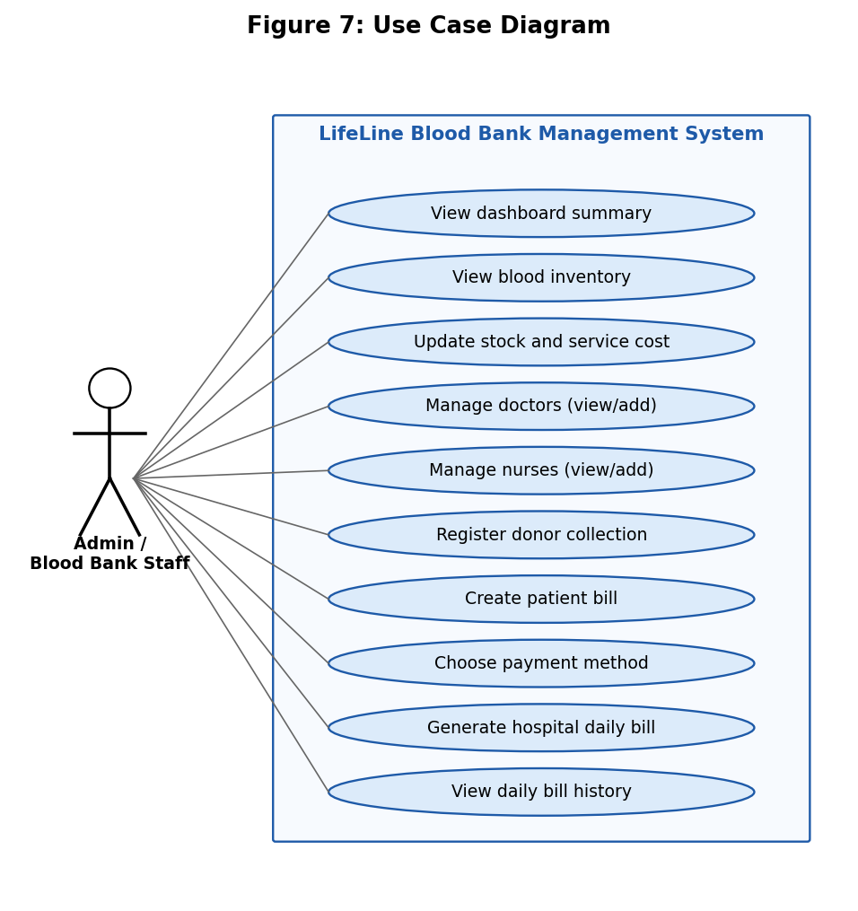
Figure 7: Use Case Diagram

5. TOOLS AND CONCEPTS USED

5.1 Development Environment
- Language: Python 3
- IDE: Visual Studio Code
- GUI toolkit: Tkinter, including ttk (Treeview, Combobox, Scrollbar, Style) and messagebox
- Database: SQLite through Python's built-in sqlite3 module
- Date/time: datetime (standard library), used for timestamps and for the daily bill date
- No third-party packages or external servers are used.

5.2 Core Python Concepts Demonstrated
- Variables, constants, and f-strings — colour constants such as NAVY and RED, and formatted output like f"₹{cost:,.2f}".
- Functions and nested functions — every page is a function, and each contains inner functions for its button actions and refresh logic.
- Lambda expressions — used where a callback needs to capture a loop variable, for example command=lambda n=name, f=func: navigate(n, f) for the sidebar buttons.
- Data structures — a dictionary (nav_buttons, current_page), a list of tuples (pages, seed data for tables), and a set comprehension to read the existing column names of the nurses table.
- Exception handling — try/except ValueError blocks around number conversion, so that invalid input shows a message instead of crashing the program.
- Event-driven programming — button commands, bind("<KeyRelease>") for the live total, trace_add("write", ...) on a StringVar, and root.protocol("WM_DELETE_WINDOW", ...) for a clean exit.
- Canvas drawing — the logo, the blood-drop artwork, and the bar chart are drawn with create_oval, create_polygon, create_rectangle, and create_text.

5.3 Database Concepts Demonstrated
- Table creation with CREATE TABLE IF NOT EXISTS, PRIMARY KEY, AUTOINCREMENT, NOT NULL, and UNIQUE constraints.
- Parameterised statements using ? placeholders for INSERT, UPDATE, and SELECT, together with executemany for seed data and lastrowid to obtain the new receipt number.
- Aggregate queries with COUNT, SUM, and COALESCE, and date filtering with DATE(created_at).
- An upsert using INSERT ... ON CONFLICT(bill_date) DO UPDATE, so that regenerating the same day's bill updates the existing row instead of creating a duplicate.
- Safe schema migration using PRAGMA table_info and ALTER TABLE ... ADD COLUMN, so that databases created by earlier versions of the application keep working.
Table 3: Initial Blood Stock and Service Cost (Seed Data)
Blood group | Initial units | Service cost (₹ per unit) | Initial status
A+ | 20 | 500 | Available
A- | 10 | 600 | Available
B+ | 25 | 500 | Available
B- | 8 | 600 | Low stock
AB+ | 15 | 700 | Available
AB- | 7 | 800 | Low stock
O+ | 30 | 500 | Available
O- | 10 | 700 | Available
Total | 125 | — | 2 groups low

6. IMPLEMENTATION
The complete source code is submitted separately as a single editable .py file of roughly 1,480 lines. This section explains the purpose of each major part of that file and highlights representative listings.

6.1 Project File Overview
The file is organised from top to bottom as follows: imports and colour constants; creation of the Tk window; creation of the SQLite connection and the six tables; schema migration and seed data; ttk styling; the main layout (sidebar, content area); UI helper functions; the six page functions plus the bill history window; the navigation function and sidebar buttons; the top strip; and finally the window-close handler followed by show_dashboard() and root.mainloop().

6.2 Database Creation and Seed Data
All tables are created with CREATE TABLE IF NOT EXISTS, so the program can be started repeatedly on the same database file. Initial doctors, nurses, and blood-stock rows are inserted only when the respective table is empty:
db = sqlite3.connect(DB_NAME)
cur = db.cursor()

cur.executescript("""
CREATE TABLE IF NOT EXISTS blood_stock(
blood_group TEXT PRIMARY KEY,
units INTEGER NOT NULL,
service_cost REAL NOT NULL
);
-- ... doctors, nurses, collections, bills, hospital_daily_bills
""")

if cur.execute("SELECT COUNT(*) FROM blood_stock").fetchone()[0] == 0:
cur.executemany("""INSERT INTO blood_stock
(blood_group, units, service_cost) VALUES (?, ?, ?)""",
[("A+", 20, 500), ("A-", 10, 600), ...])

6.3 Safe Schema Migration
Because CREATE TABLE IF NOT EXISTS does not change a table that already exists, the program checks the nurses table and adds any missing columns. This allows a database made by an earlier version of the application to be used without deleting data:
nurse_columns = {
row[1] for row in cur.execute("PRAGMA table_info(nurses)").fetchall()
}
if "details" not in nurse_columns:
cur.execute("ALTER TABLE nurses ADD COLUMN details TEXT NOT NULL DEFAULT ''")
if "specialization" in nurse_columns:
cur.execute("UPDATE nurses SET details = COALESCE(specialization, '')")
if "experience" not in nurse_columns:
cur.execute("ALTER TABLE nurses ADD COLUMN experience INTEGER NOT NULL DEFAULT 0")

6.4 Reusable UI Helpers
To avoid repeating the same widget code on every page, the application defines small helper functions. make_table() builds a ttk Treeview with vertical and horizontal scrollbars and converts column names such as blood_group into readable headings; button(), heading(), and card() give every page the same look; and clear_content() removes the current page's widgets before a new page is drawn:
def make_table(parent, columns, widths=None, height=9):
holder = tk.Frame(parent, bg=WHITE, highlightbackground=BORDER, highlightthickness=1)
tree = ttk.Treeview(holder, columns=columns, show="headings", height=height)
# ... vertical and horizontal ttk.Scrollbar are attached here
for i, col in enumerate(columns):
tree.heading(col, text=col.replace("_", " ").title())
width = widths[i] if widths and i < len(widths) else 130
tree.column(col, width=width, anchor="w")
return holder, tree

6.5 Dashboard Summary and Bar Chart
The Dashboard runs four aggregate queries to fill the summary cards (total units, groups in stock, available doctors, and collection records) and then draws a bar chart directly on a Canvas. Each bar's height is proportional to its units, and groups with fewer than 10 units are drawn in red to highlight low stock:
total_units = cur.execute("SELECT COALESCE(SUM(units), 0) FROM blood_stock").fetchone()[0]

rows = stock_rows()
max_units = max([r[1] for r in rows] + [1])
for idx, (grp, units, cost) in enumerate(rows):
x = 12 + idx * 63
h = max(7, int((units / max_units) * 92))
color = RED if units < 10 else (BLUE if idx % 2 else TEAL)
chart.create_rectangle(x, 110-h, x+31, 110, fill=color, outline="")

6.6 Inventory Update with Validation
On the Inventory page the administrator selects a blood group and enters new units and service cost. The values are converted inside a try block; a negative or non-numeric entry raises ValueError, an error message is shown, and nothing is written to the database:
def update_stock():
try:
units = int(units_entry.get())
cost = float(cost_entry.get())
if units < 0 or cost < 0:
raise ValueError
except ValueError:
messagebox.showerror("Invalid values", "Enter valid non-negative units and cost.")
return
cur.execute("UPDATE blood_stock SET units=?, service_cost=? WHERE blood_group=?",
(units, cost, group_var.get()))
db.commit()
show_inventory()

6.7 Donor Collection Registration
The collection form accepts a volume such as 100 or 100ml. The chosen doctor is checked against the database again at save time, not only against the drop-down text, so only a doctor whose status is Available can be recorded. If the status is Collected, the user must confirm, and only then is one unit added to the stock of that blood group:
if st == "Collected":
confirmed = messagebox.askyesno("Confirm",
"Confirm collection was completed by authorized medical staff?")
if not confirmed:
return
cur.execute("""INSERT INTO collections
(donor, blood_group, volume_ml, doctor, status, collected_at)
VALUES (?, ?, ?, ?, ?, ?)""", (name, grp, vol, doc, st, now))
if st == "Collected":
cur.execute("UPDATE blood_stock SET units=units+1 WHERE blood_group=?", (grp,))
db.commit()

6.8 Billing and Automatic Stock Update
The billing page accepts either a unit count (for example 2) or a bag volume (for example 500ml, counted as one bag, because stock is tracked in bags rather than millilitres). A helper function converts the text to a unit count; zero, negative, or non-integer entries are rejected:
def parse_requested_units(raw_value):
raw = raw_value.strip().lower().replace(" ", "")
if not raw:
return 0
if raw.endswith("ml"):
volume = int(raw[:-2])
if volume <= 0:
raise ValueError
return 1
count = int(raw)
if count <= 0:
raise ValueError
return count

When the user presses Generate bill & update stock, the function create_bill() validates the input, compares the requested count with the available stock, handles the payment method, inserts the bill, and reduces the stock in the same commit. The receipt number is the new row's lastrowid, shown with leading zeros:
available, unit_cost = stock
if count > available:
messagebox.showerror("Insufficient stock", f"Only {available} unit(s) of {grp} are listed in stock.")
return
# Online Payment (Demo) asks for confirmation -> "Paid (Demo)"; otherwise "Cash Due"
total = count * unit_cost
cur.execute("INSERT INTO bills (...) VALUES (?, ?, ?, ?, ?, ?, ?, ?)", (...))
receipt_id = cur.lastrowid
cur.execute("UPDATE blood_stock SET units=units-? WHERE blood_group=?", (count, grp))
db.commit()

The estimated total shown above the button is refreshed while the user types, because calc_total() is bound to the <KeyRelease> event of the units box and to changes of the blood-group drop-down through trace_add.

6.9 Hospital Daily Bill (Upsert)
The hospital daily bill adds up all patient bills created on the current date. Because bill_date is declared UNIQUE, the SQL upsert updates the existing row if the summary for that date was already generated, so there is never more than one hospital bill per date. The bill number is shown in the form H-00001:
totals = cur.execute("""SELECT COUNT(*), COALESCE(SUM(units), 0), COALESCE(SUM(total), 0)
FROM bills WHERE DATE(created_at)=?""", (today,)).fetchone()
cur.execute("""INSERT INTO hospital_daily_bills
(bill_date, patient_bills, total_units, total_amount, generated_at)
VALUES (?, ?, ?, ?, ?)
ON CONFLICT(bill_date) DO UPDATE SET
patient_bills=excluded.patient_bills,
total_units=excluded.total_units,
total_amount=excluded.total_amount,
generated_at=excluded.generated_at""", (today, *totals, generated))

6.10 Navigation and Application Exit
The sidebar is created from a list of (name, function, symbol) tuples. A lambda with default arguments captures each loop value so that every button opens its own page, and navigate() highlights the active button before calling the page function. When the window is closed, the handler commits and closes the database connection:
for name, func, symbol in pages:
btn = tk.Button(sidebar, text=f" {symbol} {name}",
command=lambda n=name, f=func: navigate(n, f), ...)
nav_buttons[name] = btn

def on_close():
db.commit()
db.close()
root.destroy()
root.protocol("WM_DELETE_WINDOW", on_close)
show_dashboard()
root.mainloop()

6.11 Execution Instructions
- Required Python version: 3.8 or later, with Tkinter available (included in the standard Windows and macOS installers).
- Required libraries: none beyond the standard library (tkinter, sqlite3, datetime).
- To run: save the script (for example as capstone_4.py) and run python capstone_4.py.
- On first run the file lifeline_stylish.db is created in the current folder and filled with the sample doctors, nurses, and blood stock. To reset the application, close it and delete this file.
- There is no login screen; the application opens directly on the Dashboard.

7. TESTING AND DEBUGGING
The application was tested in two ways. The database and billing logic was checked by running the schema-creation and seeding section of the code and the SQL statements used by the collection, billing, and daily-bill functions against a fresh SQLite database, together with the unit-parsing rules of parse_requested_units(). The graphical behaviour (pop-ups, screen refresh, and navigation) is checked by manual walkthroughs of the running application. Table 4 lists the main test cases; the Status column shows which ones were verified by the logic check and which are to be confirmed while running the application.
Table 4: Functional Test Cases
# | Test case | Input / action | Expected result | Status
1 | Database creation and seeding | First run with no database file | 6 tables created; 4 doctors, 4 nurses, 8 blood-group rows inserted | Verified (logic check)
2 | Initial stock and low-stock rule | Default seed data | Total 125 units; B- (8) and AB- (7) shown as Low stock | Verified (logic check)
3 | Valid inventory update | A+, units 40, cost 550, Save changes | Row updated and table refreshed | Run & confirm
4 | Invalid inventory input | Units = -5 or text | "Invalid values" error; database unchanged | Run & confirm
5 | Add doctor with empty name | Blank name, other fields filled | "Check details" error; no row added | Run & confirm
6 | Collection marked Collected | Valid donor, O-, 450 mL, status Collected, confirm Yes | Row saved; O- stock increases by 1 (10 → 11) | Verified (SQL); dialog to confirm
7 | Collection marked Not Collected | Valid donor, status Not Collected | Row saved; stock unchanged | Run & confirm
8 | Volume with unit text | Volume entered as 100ml | Accepted as 100 mL | Run & confirm
9 | Bag volume in billing | Units / volume = 500ml | Counted as 1 bag | Verified (logic check)
10 | Invalid units in billing | 0, -2, abc, 1.5 | Rejected with "Invalid details" message | Verified (logic check)
11 | Request above stock | Units larger than available | "Insufficient stock" error; no bill saved | Run & confirm
12 | Cash bill reduces stock | A+, 2 units, Cash at Hospital | Total ₹1,000; status Cash Due; A+ stock 20 → 18 | Verified (SQL); dialog to confirm
13 | Demo online payment | Online Payment (Demo), confirm Yes / No | Yes: Paid (Demo) bill saved; No: nothing saved | Run & confirm
14 | Daily bill generated twice | Press hospital bill button two times on the same day | Only one row for the date; values and time updated | Verified (logic check)
15 | Closing the window | Click window close button | Data committed, connection closed, window closes | Run & confirm

7.1 Additional Edge Cases Considered in the Code
- If no doctor is Available, the collection form shows "No Available Doctor" and saving is refused.
- A pathologist is always set to Available at start-up, including in databases created by earlier versions of the program.
- The volume entry in collections must be a whole, positive number; decimals are rejected.
- Totals use COALESCE(..., 0) so the dashboard and daily bill show zero instead of an empty value when there are no records.

7.2 Known Limitations Found During Testing
- The quick-action buttons on the Dashboard open pages by calling the page functions directly, so the sidebar highlight does not move to the opened page; only sidebar clicks update the highlight.
- A collection saved as Not Collected cannot later be changed to Collected from the interface, and each Collected record adds exactly one unit regardless of the volume entered.
- Doctors and nurses can be added and viewed but not edited or deleted from the interface, and availability can only be set when the person is added.
- The fonts and symbols (Segoe UI, ₹, and a few Unicode icons) display best on Windows; on other systems the fonts may be substituted.

8. RESULTS AND DISCUSSION
The completed LifeLine application successfully implements all six planned pages, a six-table SQLite database that persists across restarts, automatic stock changes on collections and bills, input validation on every form, and a separate hospital daily bill with history. All functional requirements listed in Section 3.1 were implemented in the code.

8.1 Screenshot Evidence
[STUDENT ACTION REQUIRED: Insert numbered, captioned screenshots here before final submission, taken by running the application with python capstone_4.py. At minimum include: (1) the Dashboard, (2) Blood Inventory with the Low stock rows, (3) Doctors directory, (4) Available Nurses, (5) Collections page with a saved record, (6) Payments & Bills with a generated receipt pop-up, and (7) the Hospital Daily Bill History window. Give each a figure number and a specific caption, e.g. 'Figure 8: Blood Inventory page showing B- and AB- as Low stock.' Delete this box afterwards.]

8.2 Objective Achievement
Objective (Section 2.2) | Status
GUI-based application with sidebar and dashboard | Achieved
Permanent storage in SQLite with six tables | Achieved
Live stock view with Low stock flag and stock update | Achieved
Doctor and nurse directories with add option | Achieved (view and add only)
Collections linked to available doctors; stock increases only when Collected | Achieved
Billing with stock check, automatic stock reduction, and demo payment | Achieved
Separate hospital daily bill with history | Achieved
Input validation with clear messages | Achieved

8.3 Limitations
- The application is for a single local user with no login or role-based access; anyone who can open the program can change data.
- Records cannot be edited or deleted from the interface (apart from the stock update), and there is no search or filter on the tables.
- Bills and receipts are shown on screen only; they cannot yet be exported or printed as PDF files.
- Foreign-key constraints and database transactions with rollback are not used; consistency depends on the application's own checks.
- The online payment is a simulation and the service costs are illustrative, so the system is for education and not for real medical or financial use.

9. CONCLUSION AND FUTURE SCOPE

9.1 Conclusion
This project designed and implemented LifeLine, a working blood bank management application that combines a modern Tkinter interface with a relational SQLite database. It keeps blood stock, staff directories, donor collections, patient bills, and daily hospital summaries in one place, updates stock automatically when collections and bills are saved, protects the data with validation and parameterised queries, and stores everything permanently. Compared with our minor project, which kept data only in memory, this project demonstrates a complete data-driven application built using only Python's standard library.

9.2 Learning Achieved
Building this project gave us practical experience in designing relational tables and choosing keys and constraints; writing parameterised SQL with aggregates and an upsert; migrating a database schema safely; structuring a larger Tkinter application with reusable helper functions; validating user input with exceptions; and keeping interface state and database state consistent after every action. It also taught us the value of testing business rules — such as never allowing a bill larger than the stock — before building the screens around them.

9.3 Future Scope
- Add a secure login with hashed passwords and separate roles for administrator and staff.
- Add edit, delete, search, and filter options for doctors, nurses, collections, and bills.
- Add a donor register with donation history, eligibility dates, and contact details, and track each blood bag with an expiry date.
- Add alerts or reports for low stock and expiring units, and charts of monthly collections and issues.
- Export bills, receipts, and daily hospital bills as PDF files and add print support.
- Use FOREIGN KEY constraints and database transactions for stronger data integrity.
- Package the application as a standalone executable (for example with PyInstaller) for distribution without a separate Python installation.

REFERENCES
[1] Python Software Foundation. Python 3 Documentation. https://docs.python.org/3/
[2] Python Software Foundation. tkinter — Python interface to Tcl/Tk. https://docs.python.org/3/library/tkinter.html
[3] Python Software Foundation. tkinter.ttk — Tk themed widgets. https://docs.python.org/3/library/tkinter.ttk.html
[4] Python Software Foundation. sqlite3 — DB-API 2.0 interface for SQLite databases. https://docs.python.org/3/library/sqlite3.html
[5] SQLite Consortium. SQLite Documentation (UPSERT, PRAGMA, ALTER TABLE). https://www.sqlite.org/docs.html
[6] Python Software Foundation. datetime — Basic date and time types. https://docs.python.org/3/library/datetime.html
[7] Marwadi University, Department of CSE AI ML DS. Project Report Preparation Guideline.
[8] AI-assisted development: Anthropic Claude was used for drafting this report's structure and generating the design diagrams in Section 4, based on the students' own submitted source code; all descriptions were checked against the actual code by the students.

